30 Question GA NTPC Mega Quiz Sunday 18 august 2019

S1. Ans.(b)
Sol. The Sun is directly overhead at "high-noon" on the equator twice per year, at the two equinoxes. Spring Equinox is usually March 20, and Autumnal equinox is usually September 22.

S2. Ans.(b)
Sol. The birth rate is the total number of live births per 1,000 of a population in a year or period.

S3. Ans.(d)
Sol. The Geysers is the world's largest geothermal field, containing a complex of 22 geothermal power plants,it is located in San Francisco.

S4. Ans.(d)
Sol. Asia is the largest continent in the world.

S5. Ans.(b)
Sol. On 23 December 1912, a Bomb was thrown at the Viceroy Lord Hardinge when his procession was moving from ChandniChowk. In the trial of this Delhi Conspiracy Case, Basant Kumar Biswas, Amir Chand and AvadhBehari were convicted and executed.

S6. Ans.(a)
Sol. In 1908 a revolutionary conspiracy was intrigued to kill the Chief Presidency Magistrate D.H. Kingford of Muzaffarpur. The task was entrusted to Khudiram Bose and PrafullaChaki. The case saw the trial of a number of Indian nationalists of the AnushilanSamiti in Calcutta, under charges of "Waging war against the Government" of the British Raj. Chittaranjan Das defended AurbindoGhosh in the Alipore bomb case.

S7. Ans.(d)
Sol. Raja MahendraPratap Singh was a freedom fighter, journalist, writer, and Marxist revolutionary social reformist of India and President of first Provisional Government of India. He actively participated in the revolutionary movement within and outside India.

S8. Ans.(c)
Sol. The founding president of Ghadar Party was Sohan Singh Bhakna and LalaHardayal was the co-founder of this party. Headquarters of the movement were set up at Yugantar Ashram in San Francisco.
S9. Ans.(c)
Sol. Rash Behari Bose was a revolutionary leader against the British Raj in India and was one of the key organisers of the Ghadar Mutiny and later, the Indian National Army.

S10. Ans.(b)
Sol. Economic growth is the increase in the inflation-adjusted market value of the goods and services produced by an economy over time.

S11.Ans(b)
Sol. Article 280 provides for a Finance Commission as a quasi-judicial body. It is constituted by the President every fifth year or even earlier. The distribution of the net proceeds of taxes to be shared between the Centre and the states and the allocation between the states, the respective shares of such proceeds.

S12. Ans.(a)
Sol. Narmada river of peninsular India is distinct from the remaining three.

S13. Ans.(b)
Sol. The Union Territories are administered by the President through an administrator, who is appointed by him with a suitable designation. Power to decide the structure of administration in the UT is vested in Parliament. Parliament was empowered to create a legislature or council of ministers or both for a Union Territory via Constitution.

S14.Ans(b)
Sol. The idea of creation of Zonal Councils was first of all mooted by the first Prime Minister of India, Pandit Jawahar Lal Nehru in 1956. The zonal councils have been established by the state reorganization act 1956 to advise on matters of common interest to each of the five zones, into which the territory of India has been divided.

S15. Ans.(a)
Sol. The northern plain of India has been formed by the interplay of three main rivers of the Northern plains are the Indus, Ganga and Brahmaputra.

S16. Ans.(d)
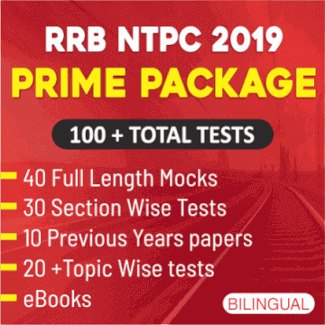
Sol. The Bay of Bengal Initiative for Multi-Sectoral Technical and Economic Cooperation (BIMSTEC) is an international organisation involving a group of countries in South Asia and South East Asia. These are: Bangladesh, India, Myanmar, Sri Lanka, Thailand, Bhutan and Nepal. The BIMSTEC states are among the countries dependent on the Bay of Bengal.

S17. Ans.(b)
Sol. The group of stars arranged in a definite pattern is called constellation. In modern astronomy, a constellation is an internationally defined area of the celestial sphere.

S18. Ans.(a)
Sol. In July 1942, the Congress Working Committee met at Wardha. Here a long resolution was passed that demanded that the “British Rule in India must end immediately”. The Wardha Resolution is also known as “Quit India Resolution”. This resolution was ratified in the All India Congress Committee at Bombay on August 7, 1942. Here a nonviolent mass struggle under the leadership of Gandhi was sanctioned in the “August Kranti Maidan”.

S19. Ans.(c)
Sol. The Bardoli Satyagraha of 1928, in the state of Gujarat, India during the period of the British Raj, was a major episode of civil disobedience and revolt in the Indian Independence Movement. The movement was led by Vallabhbhai Patel.

S20 . Ans.(c)
Sol. The Bihar famine of 1873–1874 was a famine in British India that followed a drought in the province of Bihar, the neighboring provinces of Bengal, the North-Western Provinces and Oudh. It was averted by the timely action of Northbrook.

S21. Ans.(a)
Sol. The Luni is a river of western Rajasthan state, India. It originates in the Pushkar valley of the Aravalli Range, near Ajmer and ends in the marshy lands of Rann of Kutch in Gujarat, after travelling a distance of 495 km. It is important river of Indian desert.

S22. Ans.(b)
Sol. The term regur is used for black soil.

S23. Ans.(a)
Sol. Black soil is a rich soil that is good for crops like cotton. It is found in various places around the world. It is most abundantly found in western central India.

S24. Ans.(a)
Sol. Kaziranga Wildlife Sanctuary is in the state of Assam.

S25. Ans.(b)
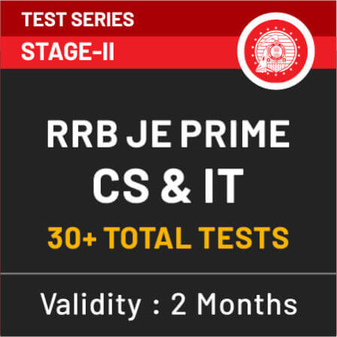
Sol. British mercantile industrial capitalist class exploited indian market by the policy of Drain of wealth. The British policies revolved around getting maximum income from land without caring much about Indian interests of the cultivators (Peasants).

S26. Ans.(a)
Sol. British investors built a modern railway system in the late 19th century it became the then fourth largest in the world and was renowned for quality of construction and service. In 1853, the first passenger train service was inaugurated between Bombay and Thane.
S27. Ans.(d)
Sol. The new class which emerged on account of British economic policies due to changed pattern of revenue collection and market consisted of moneylenders, landlords and traders.

S28. Ans.(d)
Sol. Constitution Day (National Law Day), also known as Samvidhan Divas, is celebrated in India on 26 November every year to commemorate the adoption of Constitution of India.

S29. Ans.(a)
Sol. Article 44 as a Directive Principle of State Policy directs the State to secure a uniform civil code for the citizens applicable throughout the territory of India. Its particular goal is towards the achievement of gender justice.

S30. Ans.(a)
Sol. Air India One is the call sign of any aircraft with the Prime Minister or President of India on board.

